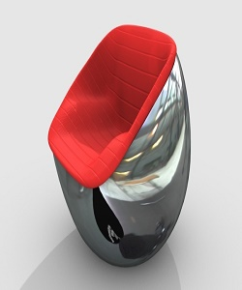

Chair Ball

$65.35

Availability: In stock

Description

This Chair will brighten up any room, with steel ball frame. This versatile lounge chair can be used as part of a living room seating arrangement or as an accent piece in a bedroom.